## Story ID 17: Emergency Notifications

User Story: As a customer I want to be up to date on all circumstances and events that may affect the time of my delivery so that I can plan accordingly.

* From the employee login screen, I am able to log on as the coordinator and access the Coordinator dashboard.

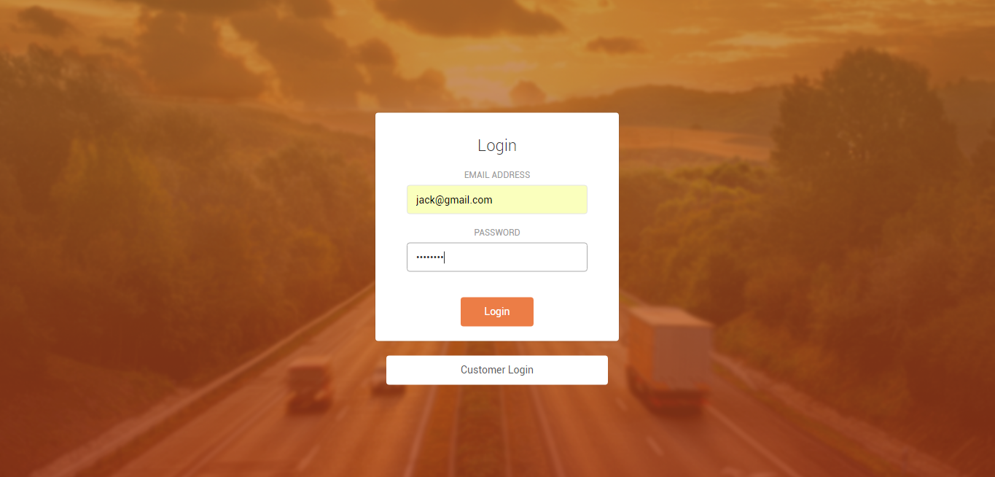

* From the Coordinator Dashboard, I am able to click on the notifications option present on the sidebar to access the notifications screen.

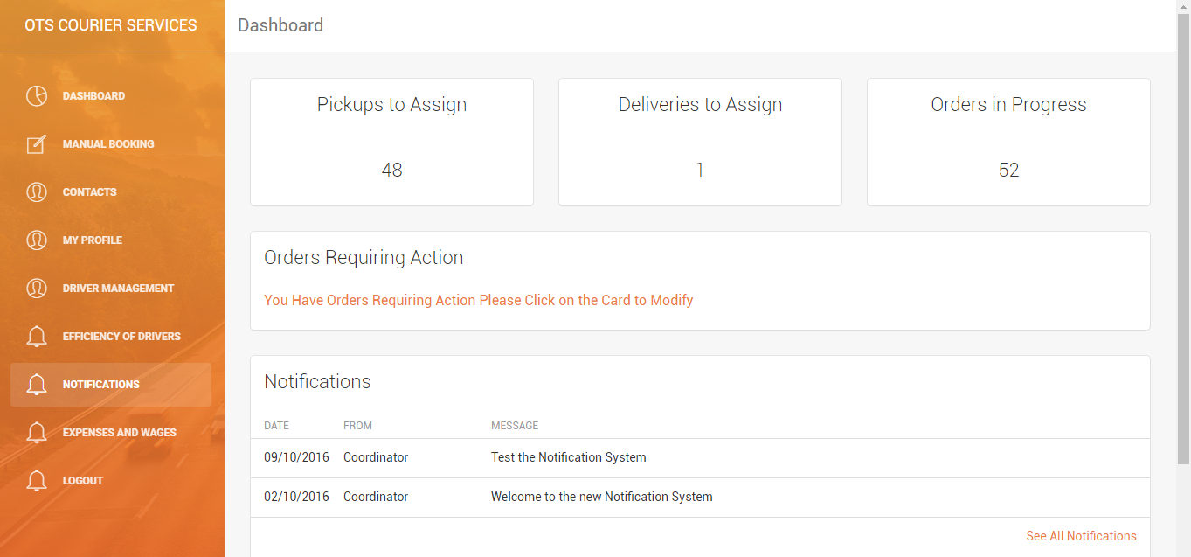

* On the notifications screen, I am able to view all notifications, and click on the 'New Message' button to access the Notification Manager page to send a new notification.

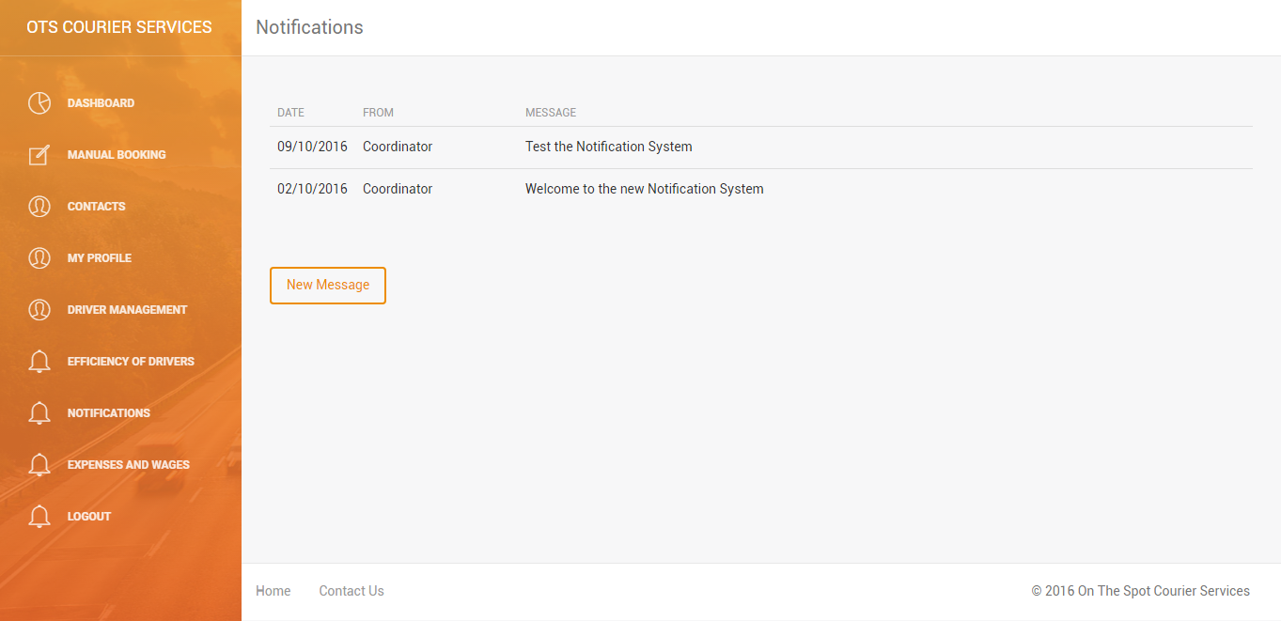

* On the Notification Manager page, I am able to enter the content of the emergency notification into the text box. Underneath, I able able to specify it as an emergency notification and then I am able to limit it to customers only.

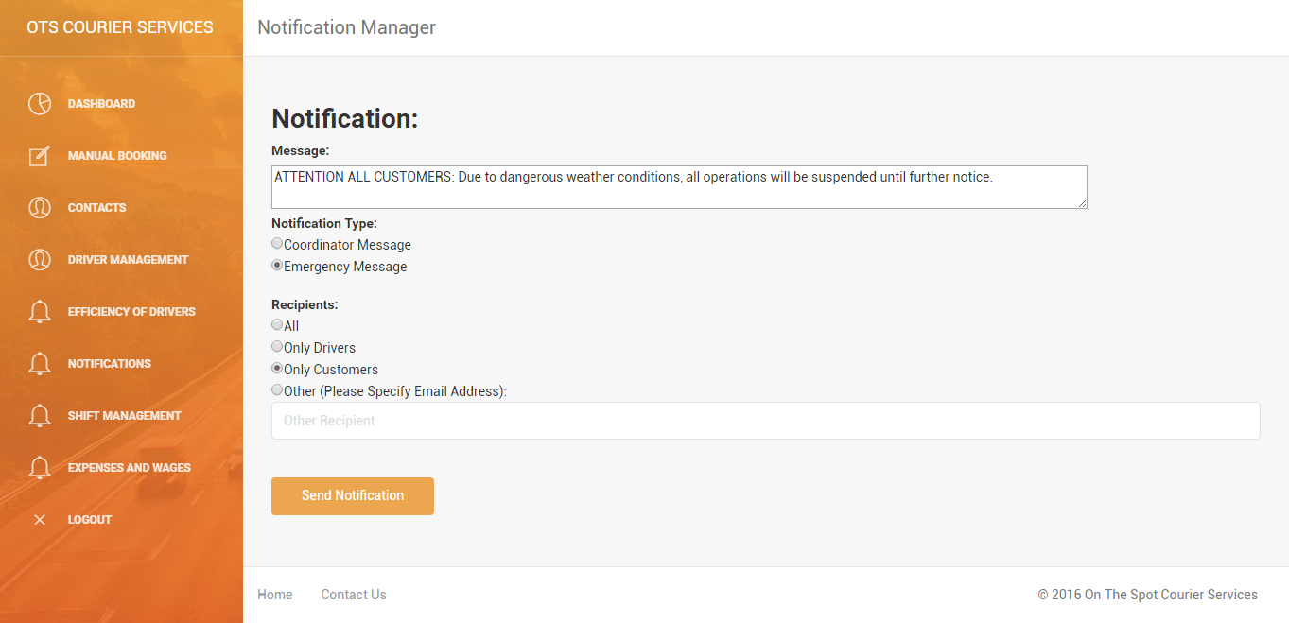

* Then, as a customer, I am then able to login via the customer login screen.

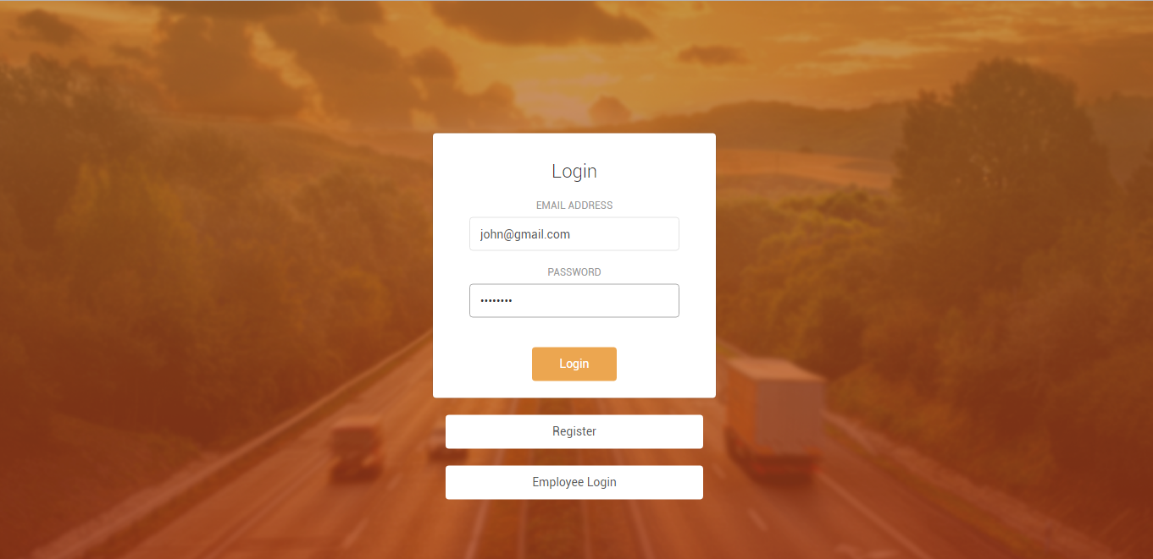

* On the main dashboard, I am able to see the new emergency notification at the right-bottom corner of the dashboard.

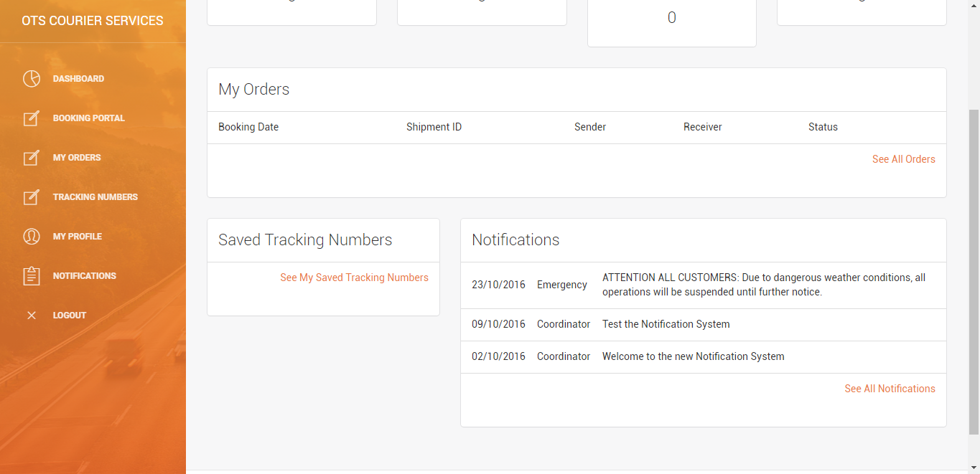

* I am also able to view the emergency notification on the notification page.

